**Write-Up – ARP spoofing protection tool**

In this write-up we are going to show and explain main parts of our code.

In the beginning we are using the 'argparse' module to analyze the user arguments in his command:

We begin to sniff Arp replies packets by create new thread that call to function 'replys_sniffing' until the user stopped the program.

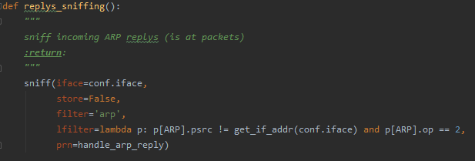

You can notice that in parmeter 'prn' of 'sniff' we call to function 'handle_arp_reply'.

In this function we check whether the 2 indicators we defined are recognized and if so, it means that the device is under attack.

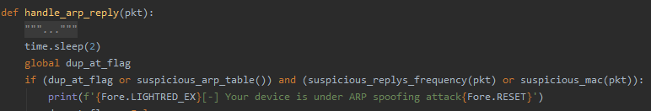

The 2 indicators we defined are:

1. Checking if there is the same mac address associated with 2 or more Ip addresses.

2. Comparing the received packet to a normal Arp reply packet **or** that there are 3 similar ARP replies at last 30 seconds.

In addition, there is the prevention flag, and if it is on then we will remove the faked-line in the victim's ARP table and after three times we'll restart the network.

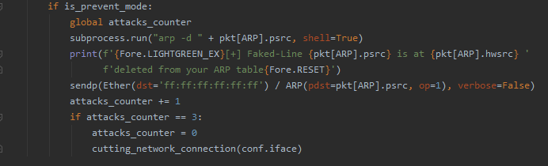

Now, we'll show a running example: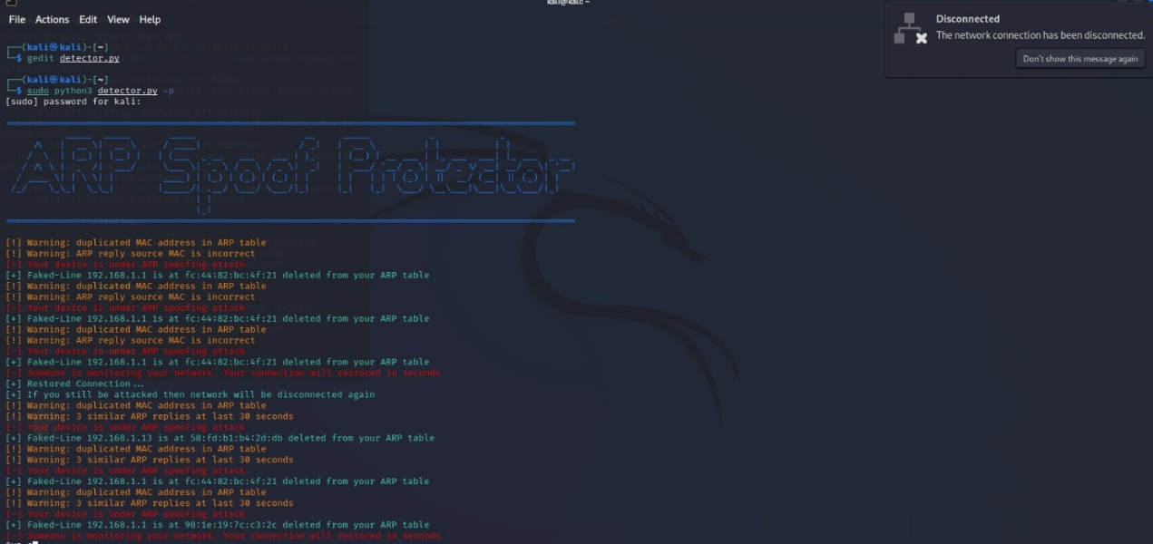

**Thank you for your reading.**